Networks / PCA / connectedness: EURUSD and USDCHF
Method 28 / pair slice of eight-major system / Alpari D1 full available history

Study setup
Logical pair: EURUSD , USDCHF
Broker symbols: EURUSD_i , USDCHF_i
Snapshot: 2026-11-03_majors_alpari_D1
Timeframe: D1
Matched return window: 1999-01-05 to 2026-11-02 (UTC bar dates)
Matched return count n: 7186
System panel n: 7127
Dropped unfinished last bar dated 2026-11-03 UTC after a tick-volume check against the prior complete day.
VAR lag (BIC): 1; GFEVD horizon H=10
System TCI: 54.0425
Complete matched rows (Excel): EURUSD-USDCHF_Network_D1.xlsx

Method carried forward
Three system-level tools on the eight-major daily log-return panel. (1) Network distance d_ij = sqrt(2*(1-rho_ij)) from Pearson correlation. (2) PCA eigenvalues of the correlation matrix R (R v = lambda v). (3) Diebold-Yilmaz total connectedness index (TCI) from a VAR with generalised forecast-error variance decomposition (GFEVD), horizon H=10; lag order chosen by BIC with maxlags=10. TCI = 100 * sum_{i!=j} theta_tilde_ij / N after row-normalising GFEVD shares. Pair reports show d_ij, rho_ij, and the directed pair spillover shares from the system theta_tilde matrix. Edges and TCI are not trading signals.

Pair results
Pearson rho: -0.747345
Network distance d_ij: 1.869409
theta_tilde[EURUSD->USDCHF] (row EURUSD, col USDCHF): 0.181336
theta_tilde[USDCHF->EURUSD] (row USDCHF, col EURUSD): 0.227509
PCA lambda_1: 3.817794
PCA variance share PC1: 0.477224

Conclusion
For EURUSD-USDCHF: d_ij=1.8694 from rho=-0.7473. Pair spillover shares 0.1813 / 0.2275. System TCI=54.04. Not a trading signal.

Pair charts
Daily closes

Daily log returns
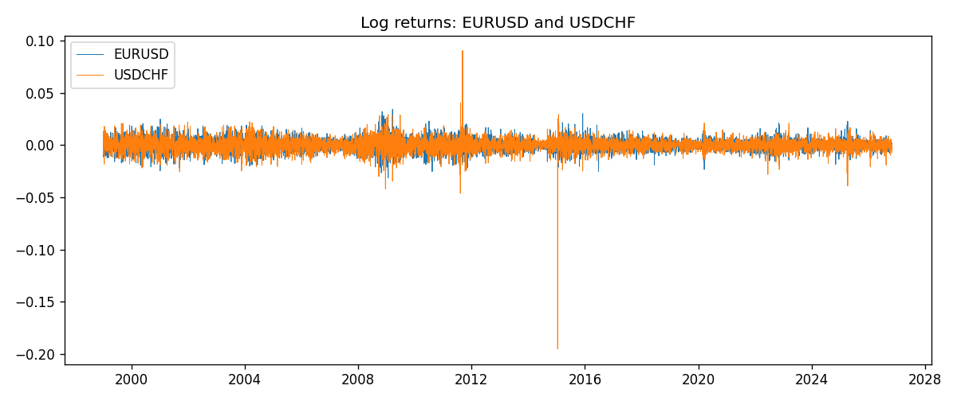

System charts (shared)
Correlation matrix

Distance matrix

PCA eigenvalues

GFEVD theta_tilde


Data report
First 15 matched rows
time | EURUSD_log_return | USDCHF_log_return
1999-01-05 | -0.0048360507 | 0.0039424743
1999-01-06 | -0.011547966 | 0.013605652
1999-01-07 | 0.0076280636 | -0.0093883841
1999-01-08 | -0.010902799 | 0.011040268
1999-01-11 | -0.007103287 | 0.0052963193
1999-01-12 | 0.0045103728 | -0.0098275602
1999-01-13 | 0.010845346 | -0.018259701
1999-01-14 | 0 | -0.0024256692
1999-01-15 | -0.010153245 | 0.01794228
1999-01-18 | 0.0036256946 | -0.0031856384
1999-01-19 | -0.00017235436 | -7.2518946e-05
1999-01-20 | -0.0031939256 | 0.0072259871
1999-01-21 | 0.0030215416 | -0.0038232689
1999-01-22 | -0.0012075213 | -0.0001445609
1999-01-25 | -0.0030251979 | 0.0024546976
Last 15 matched rows
time | EURUSD_log_return | USDCHF_log_return
2026-10-13 | 0.0037402957 | -0.0024955621
2026-10-14 | -0.0037582255 | 0.0029388325
2026-10-15 | 0.0056053107 | -0.0097855323
2026-10-16 | 0.0017724895 | -0.0036230826
2026-10-19 | -0.0025394633 | 0.0036351779
2026-10-20 | 0.0023881672 | -0.0026281224
2026-10-21 | -0.00032046717 | -0.00040027413
2026-10-22 | -0.0015949606 | -0.0048036381
2026-10-23 | -0.001338521 | 0.005652514
2026-10-26 | -0.0022706559 | 0.0018407959
2026-10-27 | -0.004152342 | 0.0026100526
2026-10-28 | 0.0022262927 | -0.0010142111
2026-10-29 | 0.0022571351 | -0.0048680164
2026-10-30 | -0.0011458446 | 0.00071594559
2026-11-02 | 0.002120569 | -0.0071459744

